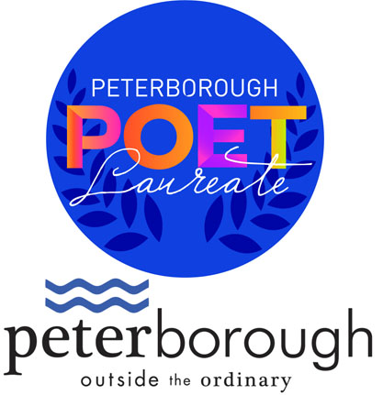
CITY OF PETERBOROUGH
POET LAUREATE PILOT PROGRAM 2021
NOMINATION FORM

INTRODUCTION
Dozens of cities across Canada have recently developed or rejuvenated Poet Laureate programs in their municipalities as a way to acknowledge and appreciate poetry, support outstanding living artists, and bring new vision and voice to the identity of their city, adding grace and substance to official civic occasions. Poets Laureate bring deeper meaning and reflection to all the work that the City does to create a vibrant community for its citizens. Poet Laureate programs enhance the value of literacy and the literary arts by building a deeper knowledge and understanding of our lives and the place where we live.

The City of Peterborough is pleased to launch its Poet Laureate Pilot Program for 2021-2022. This honourary position has been established to recognize the excellence and outstanding achievement of professional poets (both print/page and spoken word) living and working in our city and to enhance our civic identity. The Poet Laureate Pilot Program will be launched in April 2021 and the first official term will run from June 30, 2021 to April 30, 2022.

The City of Peterborough is responsible for the Poet Laureate Pilot Program which is administered by the Electric City Culture Council (EC3) under the guidance of the City of Peterborough’s Arts, Culture and Heritage Advisory Committee (ACHAC).

POET LAUREATE PROGRAM IMPORTANT DATES
Poet Laureate Pilot Program Launch: April 29, 2021
Nomination Period Opens: May 3, 2021
Information Session (Workshop and Q&A): May 10, 2021
***Nominations Due: May 25, 2021
Announcement: June 23, 2021

PETERBOROUGH POET LAUREATE
NOMINATION FORM
To be filled out jointly by Nominator and Nominee.

NOMINATOR INFORMATION
Name:

Mailing Address:

Email:

Phone Number:

NOMINEE INFORMATION
Name of Nominee:

Mailing Address:

Email:

Phone Number:

Website or social media (optional):

STATEMENTS OF AGREEMENT
Nominator: I understand and accept the conditions of the submission and selection process and I agree to keep all results confidential until the date of the public announcement.

Signature: Date:

Nominee: I understand and accept the conditions of the submission and selection process. I agree to be considered for the Poet Laureate Pilot Program and I give EC3 permission to use my biographical material for promotional purposes should I be selected. If selected as the Poet Laureate, I agree to participate fully in all activities, photography and video, media conferences, and related events. I agree to keep all results confidential until the date of the public announcement.

Signature: Date:

SUPPORT MATERIALS
Maximum five examples of work from the last 10 years. Please consult Program Guidelines for details.
Please list the title of the work, the date of publication and/or performance and, if desired, a short description for context. You may submit word documents, PDFs, video files, and/or links to online video (YouTube, Vimeo, Dropbox, etc.) as examples of your work.
1.

2.

3.

4.

5.

PETERBOROUGH POET LAUREATE APPLICATION CHECKLIST
- Completed and Signed Nomination Form
- Curriculum Vitae (CV)
- Confirmation of Residence
- Nominator’s Letter (maximum 500 words). Please consult Program Guidelines.
- Nominee’s Letter of Intent (maximum 750 words). Please consult Program Guidelines.
- Support Materials (see below and Program Guidelines)
- Artist Bio (maximum 250 words)

ACCESSIBILITY, INCLUSION, AND EQUITY
EC3 is committed to establishing fair and equitable practices for all of our programs and services in accordance with the Accessibility for Ontarians with Disabilities Act (AODA).

Persons with disabilities are encouraged to come forward at any stage of the application process to request accommodations, if needed. Members of our team will consult and can adapt processes wherever possible to provide individuals with disabilities with equal opportunity to apply.

EC3 encourages applications for the Peterborough Poet Laureate from all those who live in our diverse community and advocates for equal opportunity for all applicants in the nomination and selection process. EC3 is committed to supporting and promoting diverse artists, artistic practices, and arts communities that represent a wide cross-section of Peterborough and the surrounding area, including artists who are Indigenous, Black, or people of colour, as well as artists with disabilities, Deaf artists and those who are members of marginalized religious, sexual orientation, and gender identity groups. EC3 strives to make our juries, selection, and assessment committees equitable and inclusive by ensuring broad representation from the communities outlined above.

Completed applications must be submitted by email to peterboroughpoetlaureate@gmail.com with the subject line “Nomination for the Peterborough Poet Laureate 2021.”

The nomination deadline is May 25, 2021. Late or incomplete nominations will not be considered.

For further information contact:
Su Ditta
Executive Director (EC3)
(705) 749-9101
electriccitycc@gmail.com
www.ecthree.org

