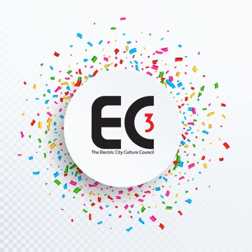

Remedies to the Negative Effects of Gentrification on the Arts
Brainstorming Solutions
Community Land Trusts
“A community land trust (CLT) is a non-profit corporation that develops and stewards affordable housing, community gardens, civic buildings, commercial spaces and other community assets on behalf of a community. “CLTs” balance the needs of individuals to access land and maintain security of tenure with a community’s need to maintain affordability, economic diversity and local access to essential services.”

Zoning, By Law and Other Initiatives
- Management of development proposals: height, location, mix, zoning
- Affordable/RGTI housing requirements
- Artists housing co-ops and/or housing/studio subsidies
- Creative spaces offset regulations
- Cultural area/zone/district/neighbourhood designation
- Creative spaces designations and development
- Creative/cultural hubs property tax incentives and public investments
- Music and other arts venues upgrade incentives ?
- 2nd and 3rd floor development incentives with arts/culture positive focus
- Heritage registers and designations need an actual plan with timelines, targets and deliverables
- Artists as small-scale property developers
- Support artists role in place-making
- Development charges: link to arts support
- Expand and refocus Community Improvement Programs (especially central area)
- Official Plan parameter broadened, also definition of downtown core
- Gentrification Tax

