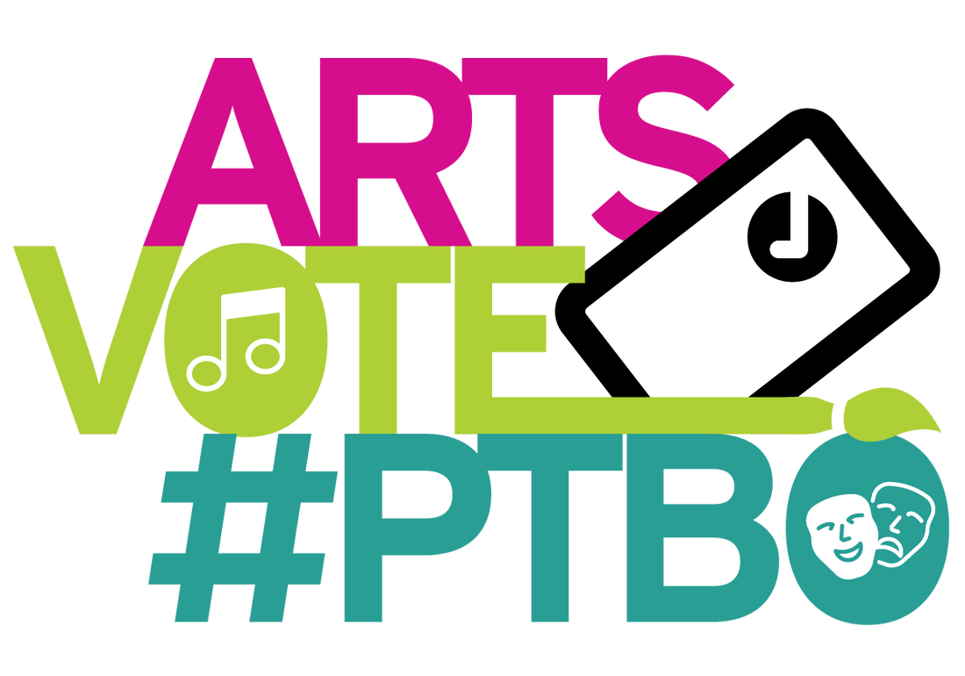
Artsvote Peterborough 2022
Art Matters Candidate Survey

COVID-19 has pushed EC3 and the Artsvote Peterborough Coalition to create an alternative way to discuss the pressing issues facing the arts and culture sector in Peterborough. The public is anxious to know how each of you will approach current challenges and opportunities in this sector that impacts thousands of citizens and contributes so much to our economy, our community cohesion and mental health. You can find more information on the Artsvote Peterborough website, which includes a number of resources related to the arts sector in Peterborough.

Please send your responses to EC3 Program Coordinator and Research Lead Gabe Pollock (ec3.research@gmail.com) by Monday, October 17 at 12:00pm.

Thank you so much for taking time out to complete the Art Matters Survey.

Please provide a Yes or No answer to the following questions and optionally provide a short (max 100-word) statement on your priorities for the City’s arts sector. Feel free to provide context to your answers to the 4 questions at the end.

1. Municipal Investments in Arts Organizations
Over the last ten years, there have not been significant increases in City funding to local arts organizations, as provided through the Community Project Grants, Community Investment Grants, and Service Grants programs. These grants support the core operations of many of the city’s key artistic organizations, which deliver programming to thousands of citizens and help keep the downtown vibrant; contributing more than $5M to the local economy and creating nearly $100M in economic spin-offs. Municipal funding is key to leveraging revenue from many other sources, however per capita municipal funding in this area remains low.
Do you support an increase to this funding and a move towards arm’s-length peer assessment for the granting process?
Answer Yes/No:

2. Support for Individual Artists
The impacts of the COVID-19 pandemic have been particularly severe on artists. It is an inherently precarious sector, with 50% of all artists in Peterborough living with a total income below $25,000. The pandemic’s two-year closure of performance and exhibition spaces, combined with spiraling inflation, have only made the situation worse. In 2021 the City of Peterborough committed $40,000 to a new program of Grants for Individual Artists, offered as a one-year pilot administered by EC3. Similar programs have been established on an ongoing basis in cities such as Kingston and Toronto. Studies show direct support to artists is essential to retaining and attracting excellence in the arts. We often forget that without artists, there is no art – and without paying artists, there is no art.
Do you support making the program of Grants for Individual Artists permanent?
Answer Yes/No:

3. Gentrification in Downtown Peterborough and the Erasure of Creative Spaces
Rapid gentrification poses a serious threat to the survival of the downtown as a rich cultural hub. The past few years have seen the loss or conversion of critical arts spaces and venues for creation, exhibition, and performance. High rents and property taxes have exacerbated the problem, not only to artists but also students, seniors and other low-income individuals who live and work in the downtown, and may be driven away.
Do you support the creation of community development programs and policies aimed at curbing the effects of gentrification, such as the establishment of community land trusts?
Answer Yes/No:

4. Supporting Diversity Equity and Inclusion
Many artists living in Peterborough have experienced decades of systemic barriers, discrimination, exclusion and marginalization in relationship to arts education, creative funding, and representation in leadership and decision making. These include BIPOC (Black, Indigenous, People of Colour) artists, 2SLGBTQ+ (Two-Spirit, Lesbian, Gay, Bisexual, Transgender, Queer or Questioning) artists, artists with disabilities, Deaf and hard of hearing artists.
Do you support the introduction of special initiatives aimed at empowering and supporting this sector? Please give examples in #5.
Answer Yes/No:

5. You can use this space to provide explanations for your answers and/or to identify priorities for Peterborough’s arts sector. (max 100 words)

We respectfully acknowledge that the land on which we work and gather is in the traditional territory of the Michi Saagiig Anishnaabe, home to the Williams Treaties First Nations, who have been the stewards and caretakers of these lands and waters for countless generations. We support them in this work, which they continue to this day.

We are grateful to be here, and pledge to listen and learn from traditional Indigenous knowledge and ways. EC3 is committed to doing all we can to further efforts at real Truth and Reconciliation, which includes providing support to the artistic work of Indigenous artists, examining the ways we do this, and providing a space and a platform for Indigenous voices to be heard and respected.

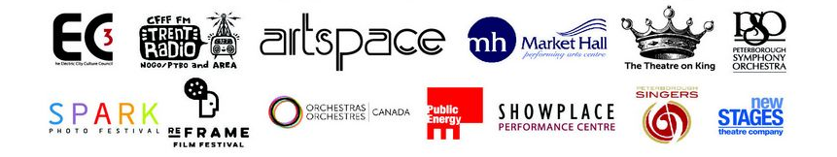
The Artsvote Peterborough Coalition includes:
